
Build your center console
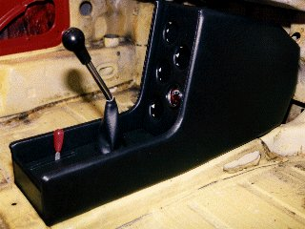

You need the following materials:
- 2 plywood sheets 400 X 800 - 5mm thick.
- Some 1.5 mm thick sheet metal.
- 2 foam sheets of 400 X 800 mm, 5mm thick.
- 1 foam plate of 400 X 800 mm, 2 mm thick.
- 1 roll of leather or vinyl – 1x1.5m
You will also need, in addition to the normal tools, a jigsaw, a drill, a stapler and woodworking glue.
If you use a thicker wood, take care to correct the dimensions of the front and the bottom faces, if not the sides of the console will be wider than the central tunnel.
The console is composed of the following elements:
- Right-hand side
- Left-hand side.
- Front.
- Bottom.
- Back wall.
- Spacers (front, upper, lower and back).
- Upper bracket.
RIGHT SIDE (1)
On one of the sheets of plywood and according to the diagram:
- Trace AB = 280mm.
- Trace the perpendicular with AB: AC = 95mm.
- Trace the parallel with AB: CD = 305mm.
- Trace = 200mm by aligning B, D and E.
- Using a compass (or of a string and a pencil), determine the points of intersection F, G, H, I, J and K (dimensions in mm) while referring in the table.
Trace line B-F-G-H-I-J-K-E.
- Trace the round-off of ray 20mm in D.
- Cut out according to contour obtained.
- Round the angles C and E with the ray 10mm.
- Bore to 100mm of ED and 25mm of EK a hole of diameter 5.5mm.
- Have on the external side and along edge A-C-D-E a band of wood of approximately 5mm thickness on 10 mm broad and round the fields.
Center 1 | Ray 1 | Center 2 | Ray 2 | Intersection
E | 340 | B | 50 | F
E | 380 | F | 265 | G
E | 410 | G | 60 | H
E | 390 | H | 100 | I
E | 350 | I | 85 | J
E | 245 | J | 110 | K
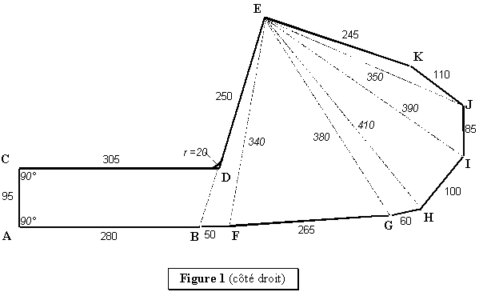

LEFT SIDE (2)
On the other sheet of plywood and according to the diagram:
- Trace AB = 280mm.
- Trace the perpendicular with AB: AC = 95mm.
- Trace the parallel with AB: CD = 305mm.
- Trace = 200mm by aligning B, D and E.
- Using a compass (or of a string and a pencil), determine the points of intersection F, M, L, G, H, I, J and K (dimensions in mm) while referring in the table.
- Trace line B-F-M-G-H-I-J-K-L-E.
- Trace line L-M.
- Trace the round-off of ray 20 mm in D.
- Cut out according to contour obtained.
- Cut out according to L-M
- Round the angles C and E with the ray 10 Misters.
- Bore to 100 mm of ED and 25 mm of EL a hole of diameter 5.5 Misters.
- Have on the external side and along edge A-C-D-E a band of wood of approximately 5 mm thickness on 10 mm broad and round the fields.
Center 1 | Ray 1 | Center 2 | Ray 2 | Intersection
E | 340 | B | 50 | F
E | 345 | F | 170 | M
M | 290 | E | 130 | L
L | 300 | M | 120 | G
L | 320 | G | 60 | H
L | 280 | H | 100 | I
L | 240 | I | 85 | J
L | 140 | J | 110 | K
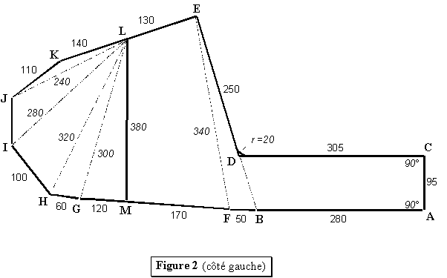
FRONT
In one of the plywood falls, cut out a plate of 145 X 310 mm, then bore the holes corresponding to the various instruments.
In the factory console, the instruments comprised a clock, a voltmeter and an oil temperature gauge, laid out vertically.
MELTS (3)
Cut out according to dimensions' of the diagram in one of the falls.
Cutting for the passage of the lever of heating comprises in the beginning a plastic trimming on its circumference and the dimensions are given to install this one. In its absence, decrease the width of approximately 5mm. 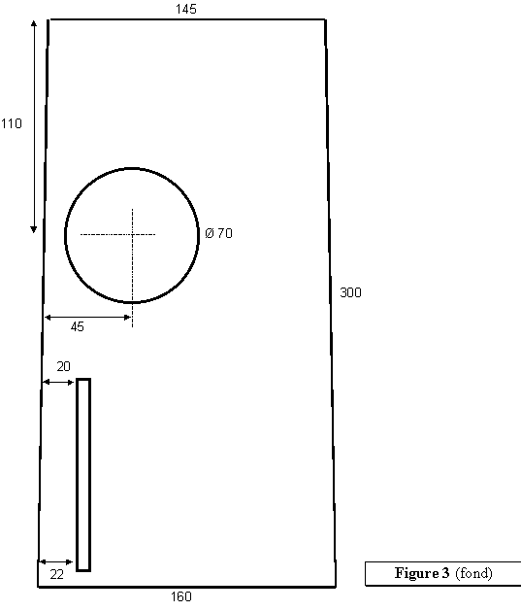

BACK WALL
Cut out in one of the sheets, a plate of 50 X 160 mm and round the higher edge.
BRACE BEFORE (4)
Cut out according to the diagram by sticking several thicknesses. 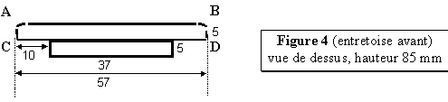TOP TRANSOM (5)
Cut out according to the diagram in sheet of 1.5mm sheetmetal in AB and CD on the same side.
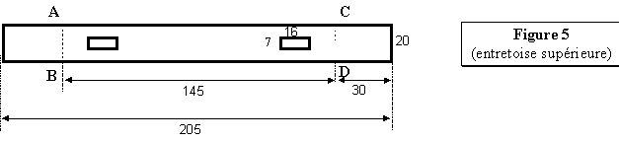
BOTTOM TRANSOM (6)
After cutting according to the diagram, cross in EC and DF.
- Compared to the face ABC:
- Fold out of AC and data base towards the back with 90°.
- Fold in CG and DH towards the back with 90°.
- Fold in Ci and JD forwards with 105°.
- Fold in IJ towards the back with 210°.
- Compared to face I-J-K-L: Fold in KL towards the back with 105°.
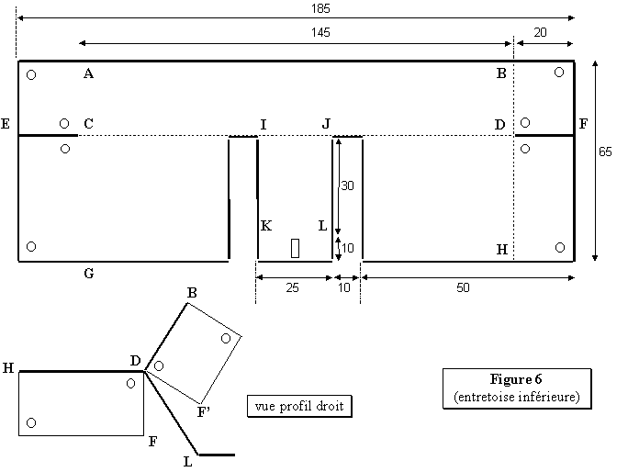
SPACER POSTPONES (7)
Cut out according to the diagram, fold in AB and CD on the same side.
Fold in EF and GH on the same side as previously.
To paint black color.
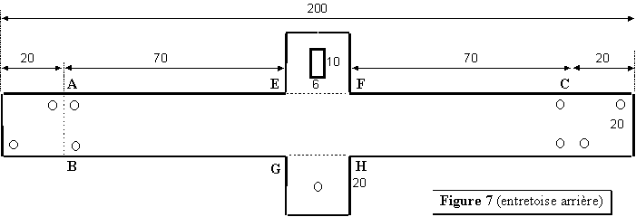

HIGHER FIXING (8)
Cut out according to the diagram, fold in AB and CD on the same side. 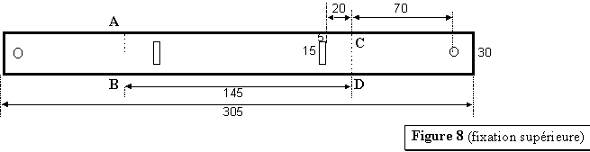
LEVER OF HEATING (9)
The lever of heating being too on the left, it proves to be necessary to modify it to be able to install the console.
Of curve, the lever will become right and shifted towards the line of 25mm..
- Start by dismounting it completely, then:
- Saw the chrome lever to 65mm of the axis then, pin towards you, fold it towards the line, according to the diagram.
- Weld a piece of the same sheet thickness, cut out according to the diagram.
- Weld a threaded rod of diameter 5mm.
- Sandpaper and make chromium plate. 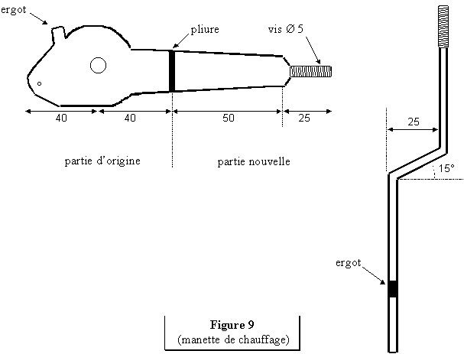
ASSEMBLY (10)
To take the two parts composing the left side and assemble them by a line of fasten internal side, fold approximately 30° and fasten the other side.
Cover each side with imitation leather after having interposed a layer of 5 mm thickness foam on the external faces (except on the edges).
Screw the bottom transom on the faces left and right-hand side of the console, the mounting foot on the case backwards, plan CDGH with horizontal and 25 mm of the lower edge, parallel face ABCD and 30 mm in withdrawal on each side ED.
Screw the top transom on the faces left and right-hand side of the console, 15 mm in lower part on sides EK, parallel face ABCD and 30 mm in withdrawal on each side ED.
Screw the back spacer with the short-nap cloth of the lower edge on the back face, the rectangular hole upwards. Then screw with the short-nap cloth of the edge on the sides of the console.
Screw the front spacer.
Position the bottom then the frontage fix a clip on the bottom, two on the frontage in correspondence of the rectangular holes designed to receive them. Cover with imitation leather, after having interposed a layer of 2 mm foam on the visible faces.
Screw higher fixing on the body, install the console, screw it on the case, then position the bottom and the frontage. Here, it is not finished, you do not have any more but to admire your work… Not too a long time! It remains you to install the manos! 