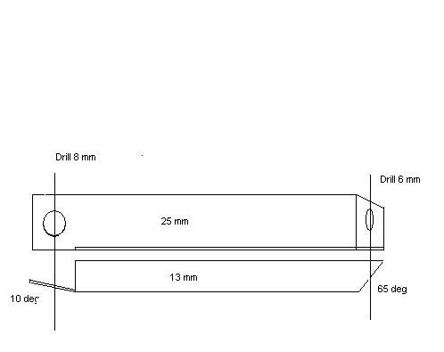
24.4 mm
(from face of M/C end to centerline of crossbar end)

